A junior project manager with a passion for agile. I am a team player with strong analytical skills that is always looking for a new challenging opportunity. 9 to 5 mentality is not in my dictionary.

Curriculum Vitae
Alexander Shijan
Nationality: Dutch
Ehrlichstraat 12
1221JB Hilversum
(+31)06-2212-8866
alexander.shijan@gmail.com
LinkedIN
Portfolio

Skills
Agile and Scum | ★★★★★
Communication | ★★★★★
Teamwork | ★★★★★
Analytical Skills | ★★★★★
Software
Microsoft Office | ★★★★★
Microsoft Project | ★★★★★
Jira | ★★★★★
Perforce | ★★★★★
Unity | ★★★★★
Unreal Engine 4 | ★★★★★
Languages
English | ★★★★★
Dutch | ★★★★★
Russian | ★★★★★

My Qualities
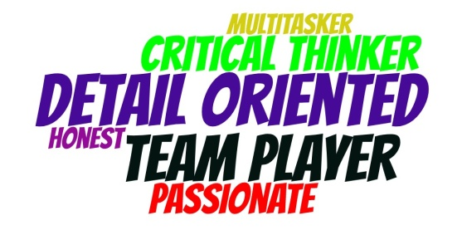

Education
2011-2018 | Bachelor Game Architecture and Design  Breda University of Applied Sciences (BUAS)

Professional Experiences
2017 -  2016 | Assistant Project Manager Internship  Breda University of Applied Sciences(BUAS)  - Assisting with supervision of 3-4 student projects, between 7 to 18 people each working with Ubisoft IPs.  - Collaborated with clients to understand business problems and convert them into requirements.  - Prepared and conducted workshops to help promote Agile methodologies.  - Coached students to ensure their project is on schedule.  - Organized weekly meetings and daily stand ups, taking meeting minutes.
2016 -  2015 | Team Lead  Grip Combat Racing (BUAS Client Project)  - Collaborated with stakeholders to insure milestones are met.  - Created sprint plans with input from the team through poker planning.  - Used Agile Methods to promote disciplined and efficient workflow.  - Maintained positive atmosphere and motivated team members.  - Managed version control through Perforce P4V.  - Helped play test levels and offered feedback.  - Ensured BUAS staff was up to date on project status.  - Engaged students from another study to produce a marketing proposal.
2015-  2014 | Design Lead  Territory RTS (BUAS Student Project)  - Updated and iterated on design documentation.  - Ensured genre design conventions were adhered to.  - Designed levels using Unity through an iterative process.  - Used Jira for bug testing and reporting.
2013 | Gameplay Designer  Project Moonscrapers (BUAS Student Project)  - Maintained and updated design documentation.  - Engaged in iterative balancing to ensure engaging game play.  - Recorded and directed a voice actor.  - Operated a showcase booth at Gamescom in Köln.  - Conducted bug testing and quality assurance.
2012-  2011 | English Conversation Teacher  Volksuniversiteit Laren  - Offered English conversation and writing practice for those wanting to improve their communication skills.
Hobbies: Tennis, Swimming, Video Games and Cooking.

